GC analysis
Reagents and their preparation
• Solution of saponin and potassium ferricyanide: 500 mg of saponin (obtainable from many manufacturers) and 2 g of potassium ferricyanide are dissolved in distilled water to make 10 ml. solution.
• Plastic disposable syringes (5 mL, Terumo, Tokyo, Japan or any other manufacturer)
• CO standard gas: 50 L (GL Sciences, Tokyo, Japan).
• Cyanmethemoglobobin reagent: Hemoglobin Test Wako (Wako Pure Chemical Industries, Ltd., Osaka, Japan).
• Cyanmethemoglobin reagent (by Sato et al. [11]): 20 g of potassium ferricyanide is dissolved in 500 mL of 1/15 M phosphate buffer solution (pH 7.1), followed by the addition of 50 mg potassium cyanide and 100 mL of 1% Triton X-100 (obtainable from every manufacturer) with gentle mixing. The mixture is made to 1 L by adding distilled water. The final pH of this reagent is about 7.2.
GC conditions
Column: Molecular Sieve 5A (60-80 mesh, 2 m x 3 mm i.d., Shimadzu Corp., Kyoto, Japan)
GC condition: a common GC instrument for packed columns with an FID is used. Carrier gas is hydrogen at a flow-rate of 40 mL/min; the column temperature is 80° C. The above separation column (Molecular sieve 5A) is connected with a stainless steel column (40 cm x 3 mm i.d.) packed with a nickel catalyst (Shimalite-Ni, Shimadzu). The stainless column is heated at 650° С in a reaction furnace (RAF-1A, Shimadzu Corp.), in which CO is converted into methane to be detected with an FID. The temperature of the injection port and detector is 150° С.
Procedure
i. The plunger of a plastic disposable syringe (5 mL, Terumo) is drawn to make a 3-mL space as shown in Q Figure 1.2.
ii. The tip of the syringe is capped with a silicone rubber plug (the detailed structure also shown in Q Figure 1.2).
iii. A 25-μL volume of whole blood is injected into the space of the above disposable syringe using a microsyringe.
iv. A 15-μL volume of the 5% saponin plus 20% potassium ferricyanide solution is also injected using a microsyringe.
v. The disposable syringe containing the above mixture is shaken well and left at room temperature for 30 min.
vi. A needle of a gas-tight syringe is inserted into the disposable syringe, and 200 μL of the headspace gas is drawn into the gas-tight syringe together with pushing the plunger of the plastic disposable syringe. The gas in the gas-tight syringe is injected into GC.
vii. When another injection into GC is required, the above procedure can be repeated.
viii. To prepare CO standard gases at various concentrations (50-2,000 ppm), various volumes of pure CO are placed in a 1,000 mL glass container, which has been filled with air. A 200-μL volume of each CO standard gas is drawn into a gas-tight syringe and injected into GC to make an external calibration curve (© Figure 1.3).
ix. Measurement of a total Hb concentration in the test blood: the cyanmethemogloblin method [11,12] is employed. The stock solution of the kit (Hemoglobin Test Wako, Wako Pure Chemical Industries, Ltd.) is diluted 10-fold. The whole blood to be analyzed should be vortex-mixed before use; 20μL of whole blood is added to 5 mL of the diluted solution and mixed. After standing for 150 min, the absorbance at 540 nm is measured against distilled water as blank test. The total Hb concentration of the test blood is easily calculated by comparing the absorbance of the test blood with that of the standard solution of cyanmethemogloblin included in the kit.
COHb is very stable and it takes as long as 150 min to convert COHb into cyanmethemogloblin completely using the reagent solution of the commerciable kit [ 11 ]. To shorten the analysis time, a hand-made reagent of Sato et al. [11] containing a larger amount (20 g/L) of potassium ferricyanide is recommendable to be used. To 5 ml of the Sato's solution (without dilution), 20 μL of the test whole blood is added, mixed well and left only for 5 min; the following procedure is the same as described above.
On the basis of the fact that 1.36 mL of CO can be bound with 1 g of hemoglobin, the COHb saturation percentage is calculated by the following equation:

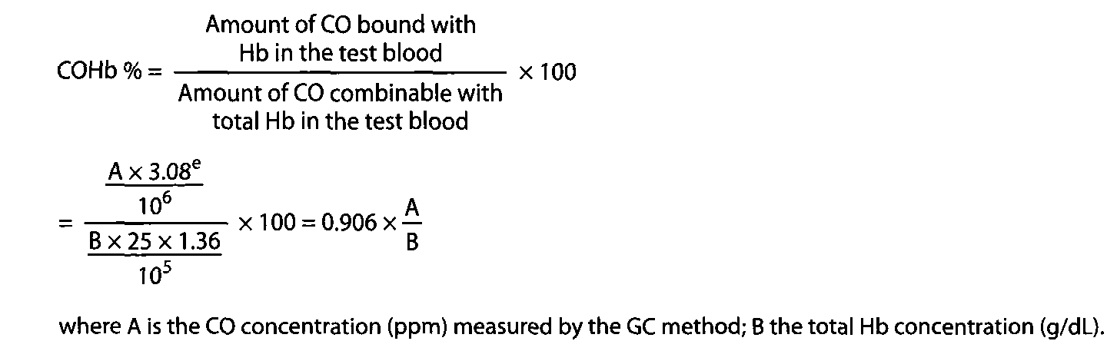

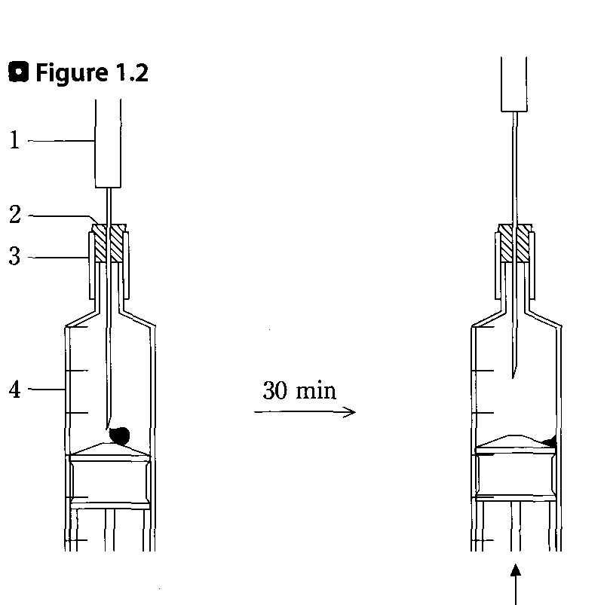
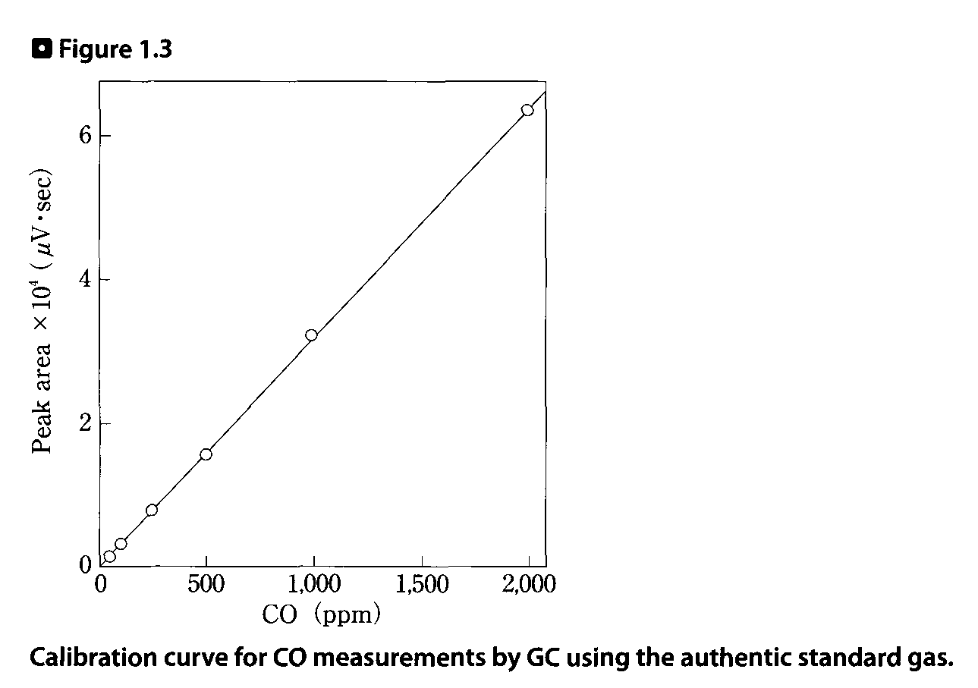
Assessment and some comments on the method
ф Figure 1.4 shows a typical gas chromatogram for the authentic CO gas. Usually a single peak due to CO appears, but when CO₂ or methane coexists, multiple peaks are detected. Both CO and CO₂ are converted into methane by nickel catalysis to be detected by an FID, but CO is neither contaminated by CO₂ nor methane, because they are well separated by the Molecular Sieve 5A column before their conversion into methane. Since hydrogen at a constant flow rate of 40 mL/ min is used in this method, care should be taken for sufficient ventilation of the laboratory.
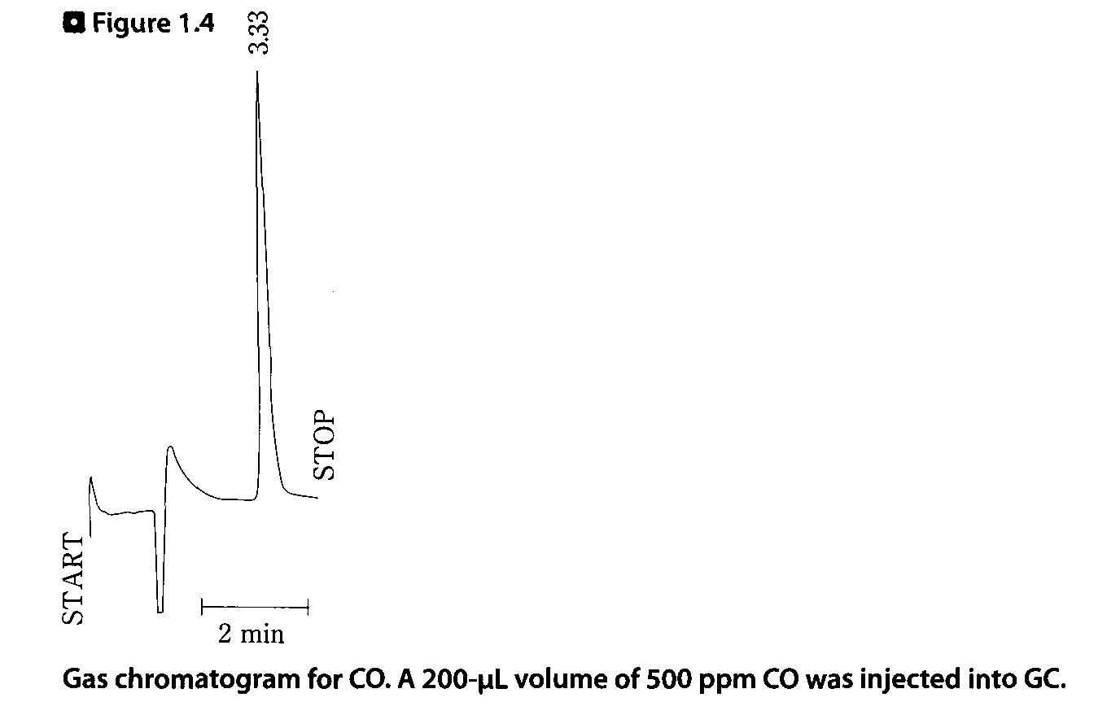
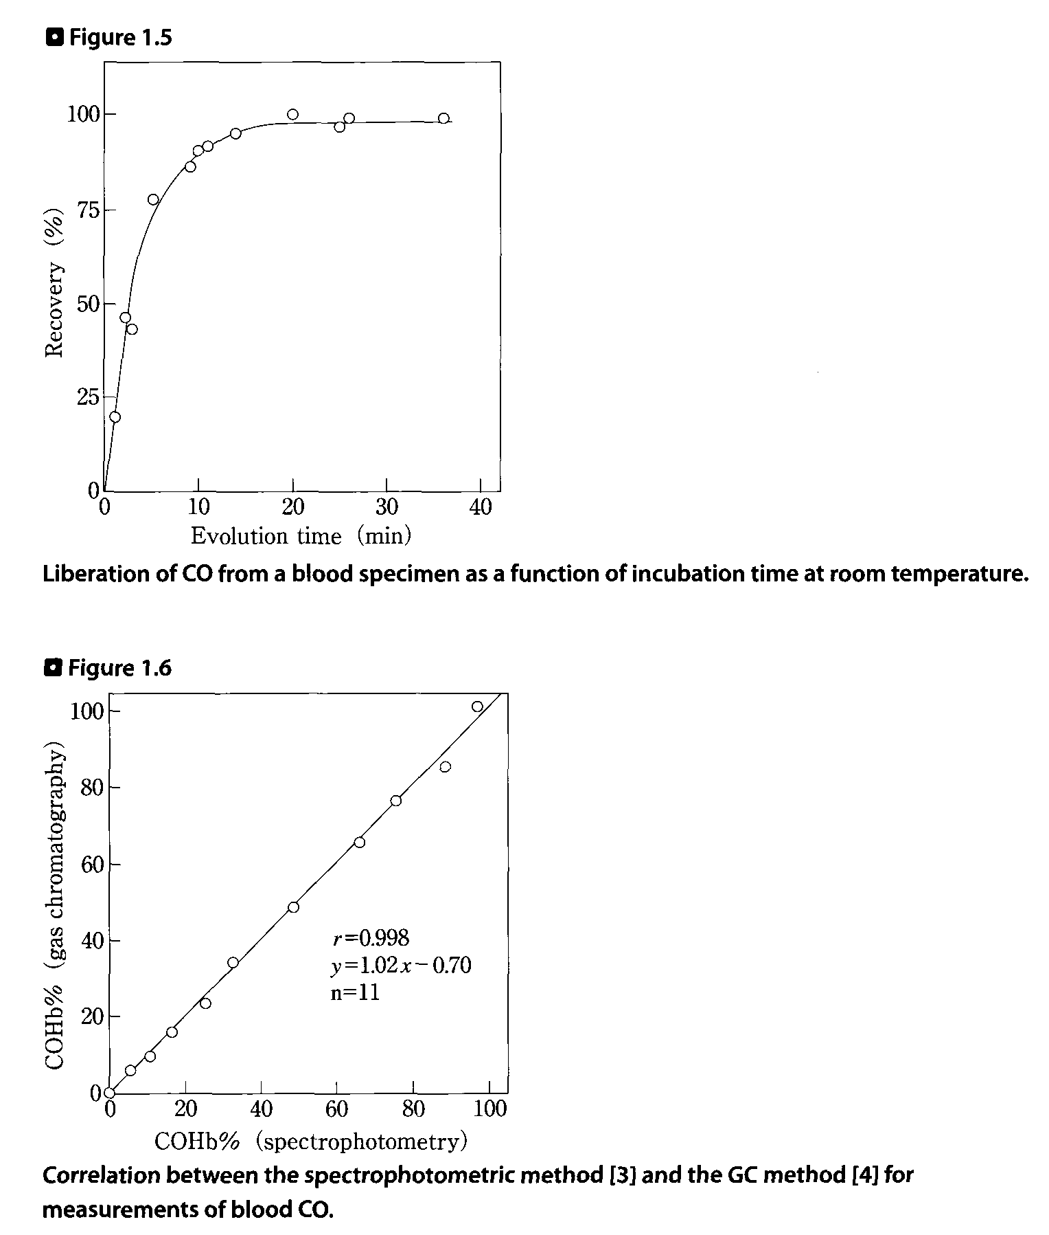
The time-course of CO liberation from a test blood by the action of the saponin plus potassium ferricyanide inside the plastic disposable syringe is shown in Q Figure 1.5. The liberation reaction was over in about 20 min; in this method, 30 min of incubation at room temperature was adopted.
The relationship between the present GC [4] and spectrophotometric [8] methods is shown in Q Figure 1.6; the correlation coefficient (r) was 0.998.
The postmortem production of COHb should be kept in mind. The appearance of Sulf-Hb in putrefied blood is also a problem for measurement of the total Hb concentration. However, since the extinction coefficient of Sulf-Hb is fortunately similar to that of cyanmethemoglobin
at 540 nm, the error of the total Hb concentration may be small, when putrefaction is slight. When the denaturation of blood is marked, the measurement of total Hb concentration becomes impossible. In this case, a method employing the analysis of iron should be used for estimation of total Hb concentration [13]. CO in the coagulated blood cannot be analyzed by the GC method.
Toxic and fatal concentrations
Since the affinity of CO to Hb is 250-300 fold higher than that of O₂ to Hb, CO interferes with the transportation of O₂ by Hb in human body. CO does not only cause hypoxia in tissues, but also causes inhibition of enzymes, such as cytochrome oxidase [1]. The poisoning symptoms as a function of blood COHb percentage are shown in О Table 1.1. However, the toxicity of CO depends upon both CO concentration in the air and duration of CO inhalation. The table shows only an outline of its toxicity; 50% or more of COHb in blood is an indicator of fatality.

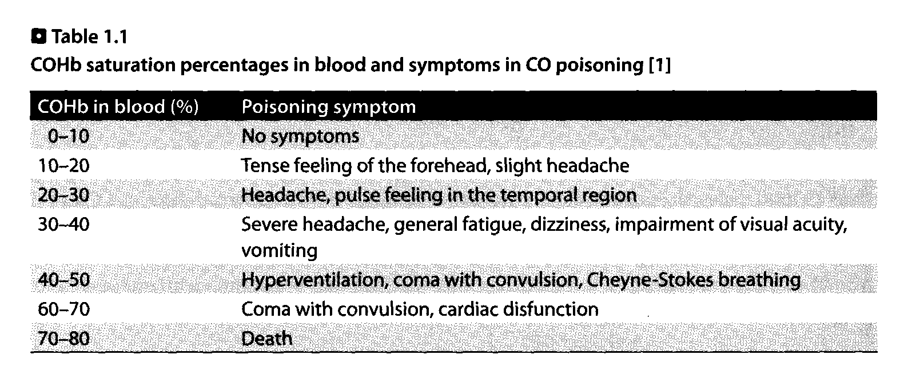
Notes
a) When the percentage of COHb in heart blood is more than 10%, it is probable that the victim has died in the fire.
b) A spectrophotometric method for COHb using separate measurements of COHb and O₂Hb [14] and a GC method using a ratio of CO peak areas before and after complete saturation with CO [15] are influenced by the presence of Met-Hb, while the spectrophotometric [3, 5,16] and GC [4,17] methods presented in this chapter are not.
c) The amount of the homogenate should be increased to 40-50μL.
d) The saponin serves to hemolyze erythrocytes, while the potassium ferricyanide converts COHb into Met-Hb to liberate CO.
e) The accurate volume of the plastic disposable syringe (Terumo) at the mark of 3 mL was 3.08 mL [4].

