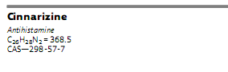
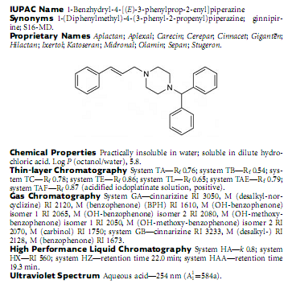
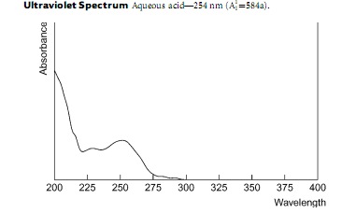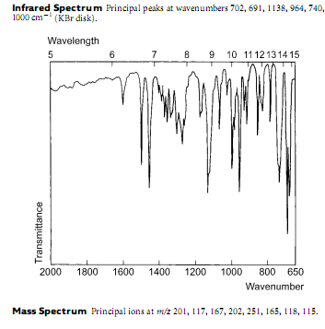
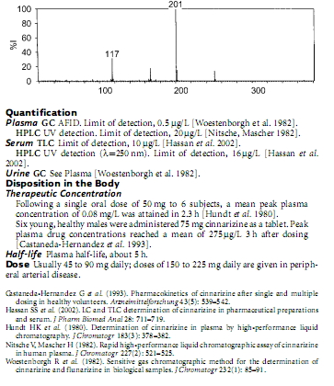
Anthony C Moffat; M David Osselton; B Widdop; Jo Watts Clarke’s Analysis of Drugs and Poisons in pharmaceuticals, body fluids and postmortem materialc. London ; Chicago : Pharmaceutical Press, 2011, 1109-1110

